In this photostory you will meet Pat Miller, his clients and their project.

Image |  | Story
1 | 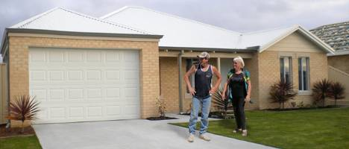 | Meet Barbara Rogers, her son Jake…
2 | 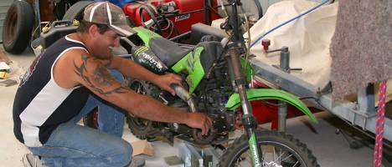 | … and the love of Jake’s life.. motorbikes.
3 | 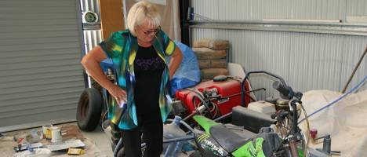 | Barbara likes bikes too, but not quite as much as Jake. When Jake moved back in with his mum about a year ago, she didn’t anticipate how much stuff he would bring with him.  They’ve decided it’s time to build a workshop, so Jake can work on the bike to his heart’s content and Barb can get her car back in the garage.
4 | 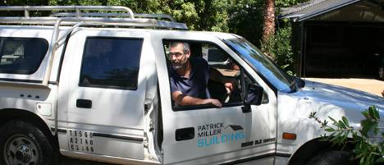 | They’re going to have a meeting with Pat Miller, a local builder.  Pat built Barbara’s current home for her a few years ago, so he knows the property well.  Barb was really happy with the job Pat did on her house and hopes he’ll take on the workshop project.
5 | 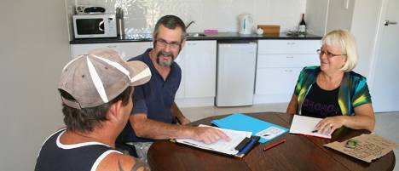 | Pat: So tell me a bit more about this workshop you’re planning to build.  Barbara: We need somewhere for Jake to pull his toys apart in comfort. Do you remember we talked about maybe needing something like this when I was planning the house but I couldn’t afford it at the time? Now I can, thank goodness. I might actually be able to get my car into the garage again.  Jake giggles nervously.
6 | 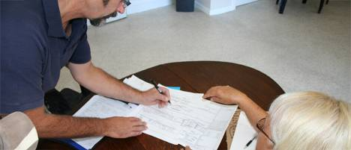 | Pat: Okay, sounds good. So can you give me a bit more detail about what you had in mind?  Jake: Err, nothing fancy, just a workshop or garage-type structure, big enough to park a car, plus a decent work space.  Barbara: And somewhere to clean up afterwards that’s not in the house would be nice as well.  Jake: I was thinking maybe uh a toilet and a wash-trough type thing, you know, something bigger than a sink.  Pat: No problem. So we’ll need power and water in and out. Are we talking single storey?  Barbara: Yes, and it needs to match up with the house from the outside. I don’t want some monstrous industrial looking shed in the middle of my garden.
7 | 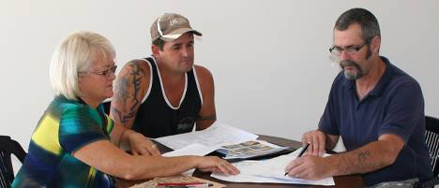 | Pat: So same construction materials and style as the house. No problem. What about ceiling height in there Jake? Are you looking for standard height, like the garage, or a bit more room?  Jake: Like the garage should be ok. And with a roller door the same as the garage.
8 | 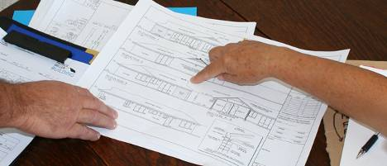 | Pat: How about windows?  Jake: Err umm… (sounds unsure)  Pat: That’s okay, you don’t have to decide that yet - I could put some into the first sketches to give you an idea but we can change them later if we need to.  Barbara: That sounds great. Thanks.
9 | 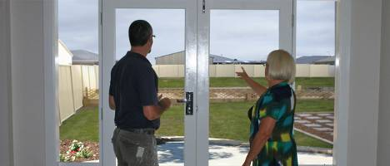 | Pat: So whereabouts are you looking to site this workshop?  Barbara: Over towards the fence there.  Pat: Right up in the back corner? Okay. I recall something on your title about an easement over there - I’ll have to check that out. It might mean we have to leave some clearance.
10 | 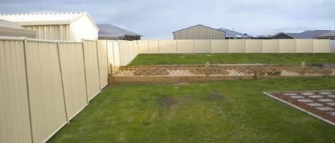 | Jake: Well...as long as it’s a fair way from the house. Oh and it needs to line up with the garage so the paving can carry through pretty much straight to it.  Pat: So are you hoping to have the same reduced setback at the side as we did for your house? You remember that took a bit of time to get through council.  Barbara: Well, yes, it would be nice.  Pat: Okay, well we can certainly look into that. I still have copies of the plans for your house and your Certificate of Title, as well as the application for variance we submitted last time. I’ll consult all of those when I do up the first sketches for your workshop.
11 | 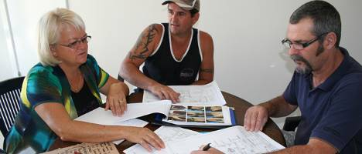 | Pat: Now Jake, what about size? What sort of floor space are you after?  Jake: Roughly single garage size, so about six by three metres for the workspace plus the loo and trough, and um some storage space too I guess. So maybe about nine by six all up?  Pat: Alright, that sounds reasonable. I think that’ll be acceptable as an outbuilding. Now to the big questions–time frame?  Barbara: Well…… we were hoping for about three months from now? My brother and his wife are coming to stay and it would be nice if it was all finished by then.  Pat: That sounds okay, although if there’s any hold up with asking for the reduced side setback it could take longer.  Barbara: Mmm. Okay.
12 | 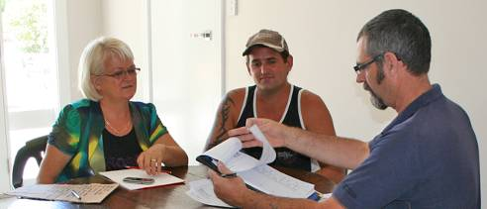 | Pat: And your budget?  Barbara: We were looking at about… $35,000?  Pat: That sounds pretty close. We’ll be able to get a more accurate figure as I develop the plans but that’s a reasonable starting point. Okay, I think that’s it for now.
13 | 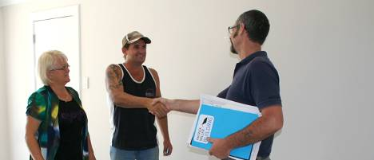 | Pat has all the information he needs for the moment.  Now he can get back to the office and get on with preparing some preliminary sketches for Barbara and Jake’s new workshop.

