A selection of plans is shown below. Your task is to examine them and decide which are sketches and which are drawings. Write ‘sketch’ or ‘drawing’ in the box next to each plan. You can save or print if you wish.

Sketches vs drawings
Plans |  | Sketch or drawing?
1 | 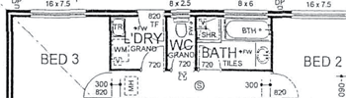
2 | 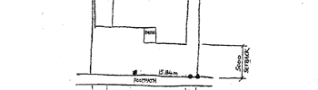
3 | 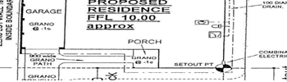
4 | 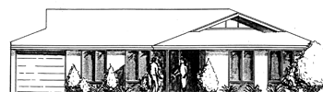
5 | 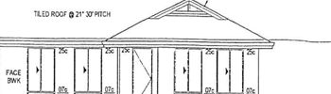
6 | 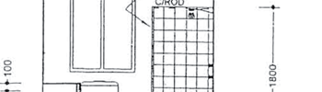
7 | 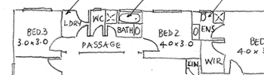
8 | 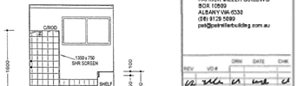
9 | 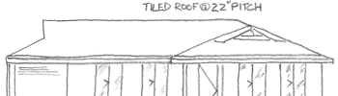
10 | 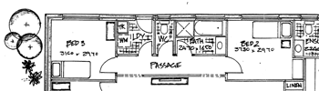
11 | 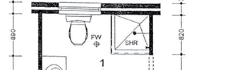

Answers

Plans 2, 4, 7, 9 and 10 are sketches. Plans 1, 3, 5, 6, 8 and 11 are drawings.

