The tools and equipment required for a site visit have been divided into two groups – measuring equipment and general tools and equipment. Your task is to match each photo below to its correct description. Write or type the picture number into the empty box next to each description. You can save or print if you wish.

Measuring equipment
Items
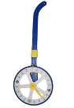  1 |  | 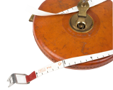  2 |  | 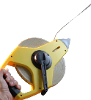  3 |  | 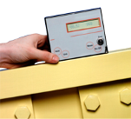  4
5  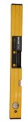 |  |  | 6  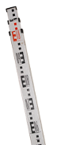 |  | 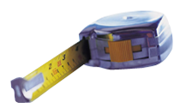  7
Descriptions |  |  |  |  |  |  | Picture #
A | Gradient or digital level – used to measure angles as a degree or inclines as a percentage.
B | Measuring wheel – used for measuring quickly (and less accurately) over long distances where a long tape would not be as efficient.
C | Steel retractable 8metre tape – the most general purpose measuring tool, used for measuring distances up to eight metres in metres and millimetres.
D | Spirit level (1200mm) – used to level and plumb existing structures to determine their trueness prior to taking measurements.
E | Measuring staff (or surveyor’s staff) – used for taking vertical approximate measurements from existing structures.
F | Open–frame tape – in 50m and 100m lengths, used for measuring site boundary dimensions and other site measurements in metres and millimetres. It is also used during the survey of a site and can be made of either steel, fibreglass or reinforced plastic.
G | Wind–up tapes – in 10m, 20m and 30m lengths, used for measuring site boundary dimensions and other site measurements in metres and millimetres. Can be made of either steel, fibreglass or reinforced plastic.

Match each photo below to its correct description. Write or type the picture number into the empty box next to each description. You can save or print if you wish.

General tools and equipment
Items
1  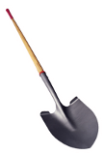 |  | 2  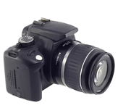 |  | 3  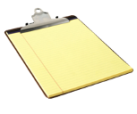 |  | 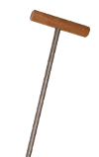  4
5  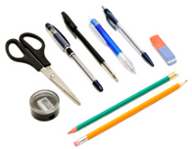 |  |  | 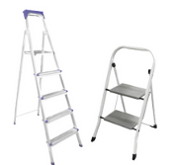  6 |  | 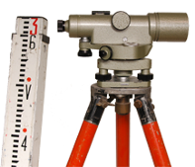  7
Descriptions |  |  |  |  |  |  | Picture #
A | Clipboard and paper – used to record all site details both in written and graphical/sketch formats.
B | Writing and sketching equipment – including HB pencils, rubber and biro.
C | Digital camera – dust, shock and water proof with interchangeable lenses and ability to print date and time graphic on the image. Used to capture site details.
D | Digging tools – used to dig holes to give a preview of the site type or to determine the location or depth of a footing for an existing structure. Dial before you dig though!
E | Probing metal stake – used to determine the location of septic tank lids and leach drains for an existing structure. Dial before you probe though!
F | Automatic level and staff – used in conjunction with a tripod to take spot levels for the purpose of developing contours as part of the site survey. Two people needed to use this equipment.
G | Ladder/step ladder with rubber feet and gutter protector – used to access an existing structure to take measurements or provide detail.

Answers

Measuring equipment
Descriptions |  | Picture #
A | Gradient or digital level | 4
B | Measuring wheel | 1
C | Steel retractable 8metre tape | 7
D | Spirit level (1200mm) | 5
E | Measuring staff (or surveyor’s staff) | 6
F | Open–frame tape | 3
G | Wind–up tapes | 2

General tools and equipment
Descriptions |  | Picture #
A | Clipboard and paper | 3
B | Writing and sketching equipment | 5
C | Digital camera | 2
D | Digging tools | 1
E | Probing metal stake | 4
F | Automatic level and staff | 7
G | Ladder/step ladder with rubber feet and gutter protector | 6

